### **Task 5 The locate command cont..**

1. **Create a file within Documents directory, add to is a file named pad.md**

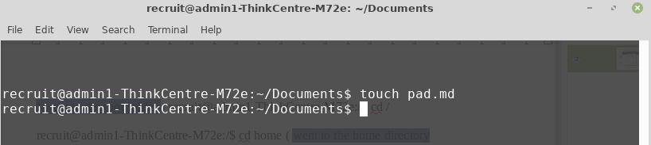

1. **change the working directory to Desktop, then create a folder and name it work**

recruit@admin1-ThinkCentre-M72e:~/Documents$ cd /home/recruit/Desktop

recruit@admin1-ThinkCentre-M72e:~/Desktop$ mkdir work

1. **copy pad.md to the currently working directory as pad_copy.md**

recruit@admin1-ThinkCentre-M72e:~/Desktop/work$ cp pad.md pad_copy.md

1. **update the database used by locate by running locate updatedb.**

recruit@admin1-ThinkCentre-M72e:~/Desktop$ locate updatedb

/etc/updatedb.conf

/etc/alternatives/updatedb

/etc/alternatives/updatedb.8.gz

/usr/bin/updatedb

/usr/bin/updatedb.mlocate

/usr/share/man/man5/updatedb.conf.5.gz

/usr/share/man/man8/updatedb.8.gz

/usr/share/man/man8/updatedb.mlocate.8.gz

recruit@admin1-ThinkCentre-M72e:~/Desktop$ ( Database updated)

1. **change the working directory to the previous one (cd -)**

recruit@admin1-ThinkCentre-M72e:~/Desktop$ cd -

/home/recruit/Documents

1. **use locate to find pad_copy.md**

recruit@admin1-ThinkCentre-M72e:~$ locate "*pad_copy.md"

/home/recruit/Desktop/pad_copy.md